A000-AM,C-Taino-Celt-Casimiroid-Ceremonial-Porphyritic Rhyolite-1000 CE

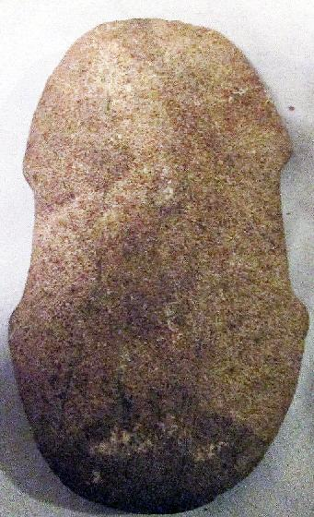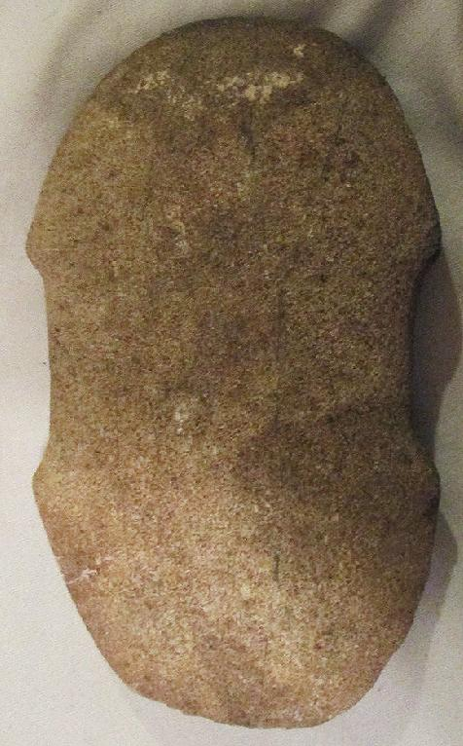

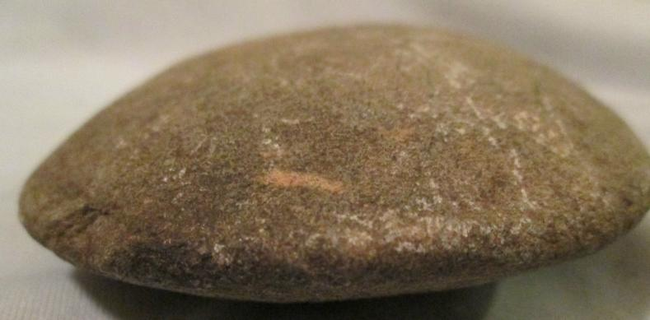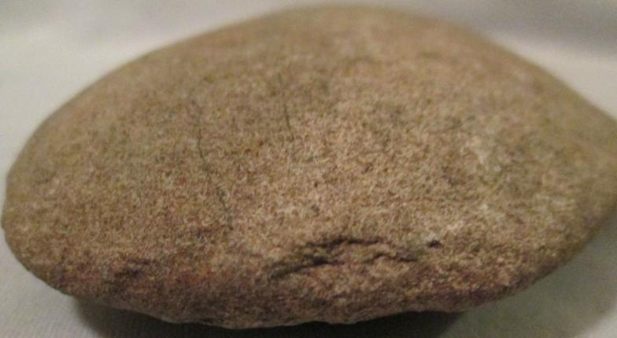

AM,C-Taino-Celt-Casimiroid-Ceremonial-Porphyritic Rhyolite-1000 CE

Case No.: 18

**Accession No.**

**Formal Label:** AM,C-Taino-Celt-Casimiroid-Ceremonial-Porphyritic Rhyolite-1000 CE

**Display Description:**

**This** Casimiroid ceremonial celt in porphyritic rhyolite was never intended for a utilitarian use. Its vey wide haftin suggests that it was fasten to a large handle to be used by th equivalent of a marshall at tribal gatherings in which the large ceremonial axe displayed the power of the Cacique convening the meeting.

**LC Classification:**

**Date or Time Horizon:**

**Geographical Area:**

**Map:**

**GPS coordinates:**

**Cultural Affiliation:**

**Media:**

**Dimensions:**

**Weight:**

**Condition:**

**Provenance:**

**Discussion:**

**References:**